Structures

An ion is an atom which has lost or gained electrons to achieve a full outer shell.
An isotope is an atom with a different number of neutrons, but the same number of protons.
The number of protons inside an atom does not change.

Atoms have a neutral charge as there are the same number of protons as electrons, so the charge cancels out.

Isotopes have the same chemical properties, but different physical properties, e.g. density and melting/boiling points.

Hydrogen has 3 isotopes:
 | Protons | Neutrons | Electrons
Hydrogen (Protium) | 1 | 0 | 1
Deuterium | 1 | 1 | 1
Tritium | 1 | 2 | 1

Tritium is densest, while protium has the lowest boiling point.

Relative atomic mass

Relative atomic mass – the mass of one atom compared to 1/12 of the mass of 1 atom of carbon-12.

Relative isotopic mass – the mass of an isotope compared to 1/12 of the mass of 1 atom of carbon-12.

To calculate relative atomic mass:
- For each isotope, multiply the mass by the abundance
- Sum these numbers
- Divide the sum by the total abundance (usually 100%)

E.g. for Cl, 75% is ³⁵Cl, and 25% is ³⁷Cl:

Mass Spectroscopy

This is where an isotope is:
- Vapourised
- Ionised by knocking off an electron
- Deflected across a magnetic field
- Bent differently depending on mass
- Detected
- Used to produce a mass spectra
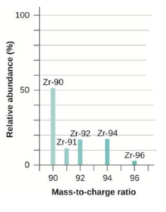
This mass spectra is used to find the relative atomic mass in the same way as normally, by dividing the sum of the masses * abundances by the total abundance, which will probably not be 100.

Ions

The following charges must be remembered:
- NO₃⁻
- CO₃²⁻
- SO₄²⁻
- OH⁻
- NH₄⁺
- ZN²⁺
- Ag⁺

